**Hall Table**

* **Create Query:**

**Create table of name “HALL”, having attributes ID (PK), HNAME, ADDRESS and CONTACT_NO.**

CREATE TABLE HALL

(ID NUMBER(4) PRIMARY KEY,

HNAME VARCHAR2(20),

ADDRESS VARCHAR2 (50),

CONTACT_NO VARCHAR2 (15));

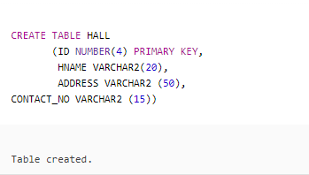

* **Insert Queries:**

INSERT INTO HALL VALUES

(5001, 'AL-JANNAT', 'Khokar Chowk, Block C-2, Township, Lahore', '+92-42-35110955');

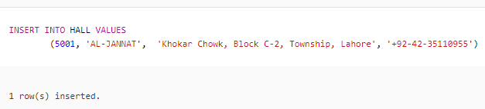

INSERT INTO HALL VALUES

(5002, 'DEWAN-E-KHAAS', 'Gaddafi Stadium Gate # 6 to 9, Lahore', '+92-42-35715560');

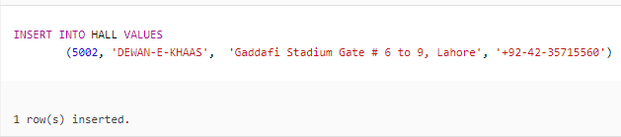

INSERT INTO HALL VALUES

(5003, 'MUSKAN', 'Al-Mumtaz Road, Lahore', '+92-42-35606510');

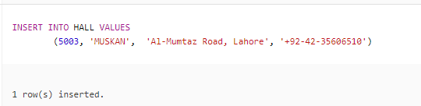

INSERT INTO HALL VALUES

(5004, 'SHALAMAR CASTLE', 'Main Canal Bank Road, Mughalpura, Lahore',

'+92-321-4677377');

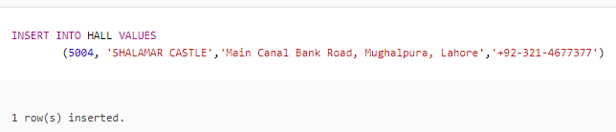

INSERT INTO HALL VALUES

(5005, 'TAJ MAHAL','Ferozepur Road, Lahore','+92-42-35864553');

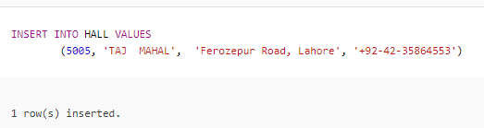

INSERT INTO HALL VALUES

(5006, 'LAHORE CASTLE','Nespak Housing Society، Sutlej Ave، Lahore', '+92-42-35189212');

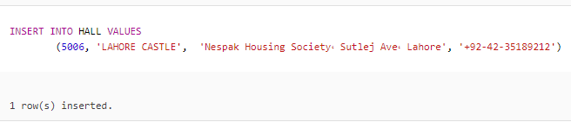

INSERT INTO HALL VALUES

(5007, 'MUGHAL-E-AZAM', ‘Usmani Road, Lahore', '+92-320-4469061');

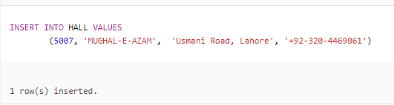

* **Delete Queries:**



**Delete row having ID 5008.**

DELETE FROM HALL

WHERE ID = 5008;

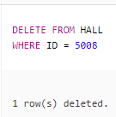

**Delete row having ID 5009.**

DELETE FROM HALL

WHERE ID = 5009;

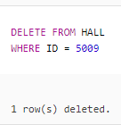

**Delete row having ID 5010.**

DELETE FROM HALL

WHERE ID = 5010;

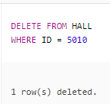

**Delete row having ID 5011.**

DELETE FROM HALL

WHERE ID = 5011;

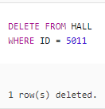

**Delete row having ID 5012.**

DELETE FROM HALL

WHERE ID = 5012;

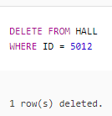

* **Update Queries:**

**Update hall name as “QASAR-E-NOOR” address as “Model Town, Lahore” and contact no as “+92-42-35916140” of row having ID 5003.**

UPDATE HALL

SET HNAME = 'QASAR-E-NOOR', ADDRESS = 'Model Town, Lahore',

CONTACT_NO = '+92-42-35916140'

WHERE ID = 5003;

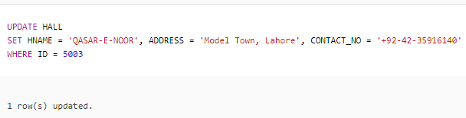



**Update hall name as “GARDENIA” address as “Main Blvd Gulshan-e-Ravi, Lahore” and contact no as “+92-42-37732548” of row having ID 5004.**

UPDATE HALL

SET HNAME = 'GARDENIA', ADDRESS = 'Main Blvd Gulshan-e-Ravi, Lahore', CONTACT_NO = '+92-42-37732548'

WHERE ID = 5004;

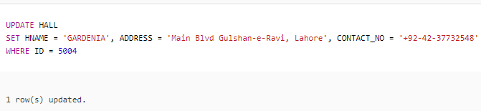



**Change contact number from +92-42-35110955 to +92-42-35110956 of ID 5001.**

UPDATE HALL

SET CONTACT_NO = '+92-42-35110956'

WHERE ID = 5001;

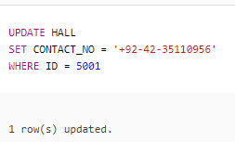

**Change ID from 5005 to 5010.**

UPDATE HALL

SET ID = 5010

WHERE ID = 5005;

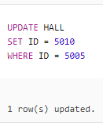



**Change address of ID 5007 as “Main Boulevard, New Garden Town, Lahore”.**

UPDATE HALL

SET ADDRESS = 'Main Boulevard, New Garden Town, Lahore'

WHERE ID = 5007;

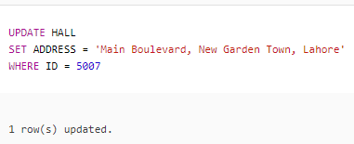

* **Other Queries:**



**Show id as HALL NUMBER and contact numbers of halls as PHONE BOOK. Show output in descending order of ID.**

SELECT ID “HALL NUMBER”, CONTACT_NO “PHONE BOOK”

FROM HALL

ORDER BY ID DESC;

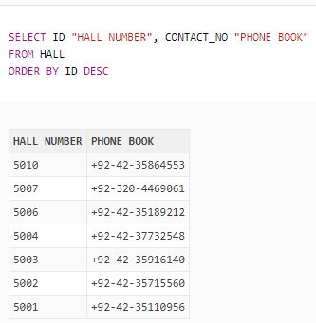

**Show hall names who have ‘T’ in their names.**

SELECT HNAME

FROM HALL

WHERE HNAME LIKE ‘%T%’;

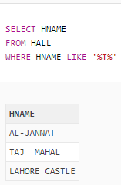

**Show name, ID and contact no of those halls whose id is greater than 5008.**

SELECT HNAME, ID, CONTACT_NO

FROM HALL

WHERE ID > 5008;

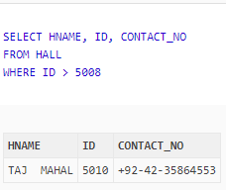

**Show address of all halls.**

SELECT ADDRESS

FROM HALL;

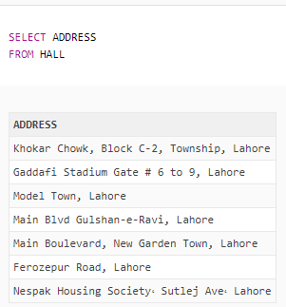

**Show id as HALL NUMBER and contact numbers of halls as PHONE BOOK. Show name and address of those halls who have ‘re’ at the end of their address.**

SELECT HNAME, ADDRESS

FROM HALL

WHERE ADDRESS LIKE ‘%re’;

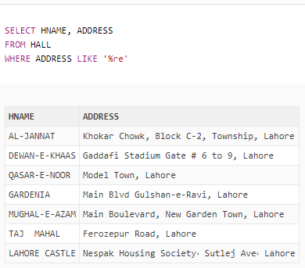

**Show hall name and address like “AL-JANNAT IS LOCATED AT Khokhar Chowk, Block C-2, Township, Lahore” as “HALL AND ADDRESS”.**

SELECT HNAME || ‘ IS LOCATED AT ‘ || ADDRESS “HALL AND ADDRESS”

FROM HALL;

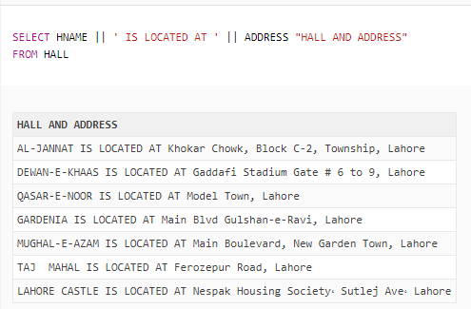

**Display all hall names from HALL with their managers.**

SELECT H.HNAME, M.MANAGER

FROM HALL H, MANAGER M

WHERE H.ID = M.ID;

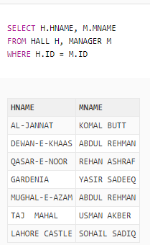

**Display hall names in ascending order.**

SELECT HNAME

FROM HALL

ORDER BY HNAME;

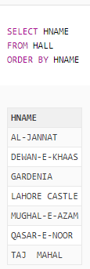

**Show name of those halls who have id 5004, 5009 or 5010.**

SELECT HNAME

FROM HALL

WHERE ID IN (5004, 5009, 5010);

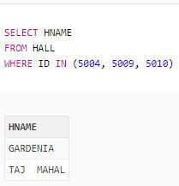

**Give name of hall and contact number whose id is 5002.**

SELECT HNAME, CONTACT_NO

FROM HALL

WHERE ID = 5002;

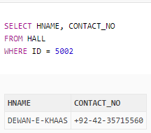

**Give name as “HALL NAME” and contact no as “PHONE NUMBER” of halls.**

SELECT HNAME “HALL NAME”, CONTACT_NO “PHONE NUMBER”

FROM HALL;

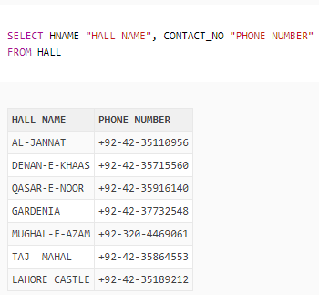

**Show hall name as “HALL” and salary of manager as “MANAGER SALARY” of those managers who have id 5001, 5004, 5007 or 5010.**

SELECT H.NAME “HALL”, SALARY “MANAGER SALARY”

FROM HALL H, MANAGER M

WEHRE H.ID = M.ID

AND M.ID IN (5001, 5004, 5007, 5010);

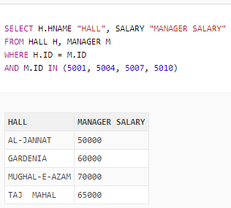

**Show hall id, hall name, hall address and manager salary of all those halls whose id is not 5001, 5003 or 5005 and salary of manager is greater than 20000 and hall name is LAHORE CASTLE.**

SELECT HALL.ID, HALL.HNAME, ADDRESS, SALARY

FROM HALL, MANAGER

WHERE HALL.ID = MANAGER.ID

AND HALL.ID NOT IN (5001, 5003, 5005)

AND SALARY > 20000

AND MANAGER.HNAME = ‘LAHORE CASTLE’;

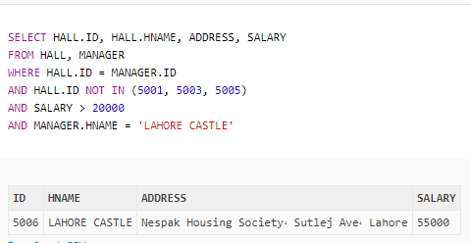

**Show address and contact number of all those halls who have name MUGHAL-E-AZAM.**

SELECT ADDRESS, CONTACT_NO

FROM HALL

WHERE HNAME = ‘MUGHAL-E-AZAM;

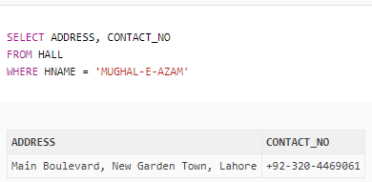

**Give id, name and contact number of all those halls who have id 5004 and hall name is GARDENIA or QASAR-E-NOOR or have 7 in their contact number.**

SELECT ID, HNAME, CONTACT_NO

FROM HALL

WHERE (ID = 5004

AND HNAME IN (‘GARDENIA’, ‘QASAR-E-NOOR’))

OR CONTACT_NO LIKE ‘%7%’;

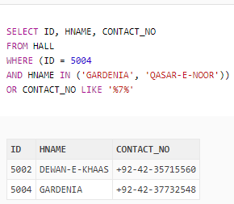

* **Function Queries:**

**Count hall names who have ‘E’ in their name as “HALL HAVE E”.**

SELECT COUNT (HNAME) “HALL HAVE E”

FROM HALL

WHERE HNAME LIKE ‘%E%’;

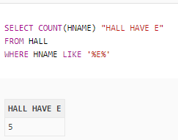

**Give hall id 10 characters long, apply left padding with “*”.**

SELECT LPAD (ID, 10, ‘*’) “ID”

FROM HALL;

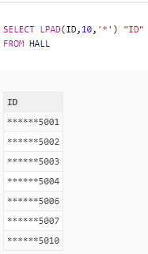

**Show hall name as first letter of every word should be capital.**

SELECT INITCAP (HNAME)

FROM HALL;

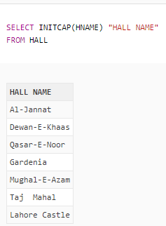

* **Sub-Queries:**

**Give name, address, contact number and salary of all those halls whose id is greater than the id of those managers whose salary is greater than 50000.**

SELECT H.HNAME, ADDRESS, CONTACT_NO, SALARY

FROM HALL H, MANAGER M

WHERE H.ID = M.ID

AND H.ID > ANY (SELECT ID

FROM MANAGER

WHERE SALARY > 50000);

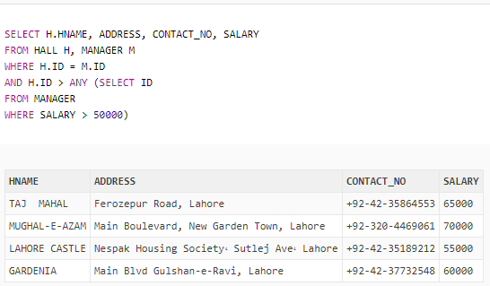

**Display name, id and contact number of all those halls whose id is greater than the id of TAJ MAHAL.**

SELECT HNAME, ID, CONTACT_NO

FROM HALL

WHERE ID > (SELECT ID

FROM HALL

WHERE HNAME = ‘TAJ MAHAL’);

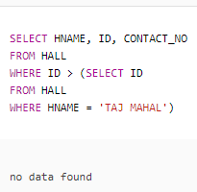

**Show name, address and contact number of all those halls whose id is not equal to the id of QASAR-E-NOOR.**

SELECT HNAME, ADDRESS, CONTACT_NO

FROM HALL

WHERE ID <> (SELECT ID

FROM HALL

WHERE HNAME = ‘QASAR-E-NOOR’);

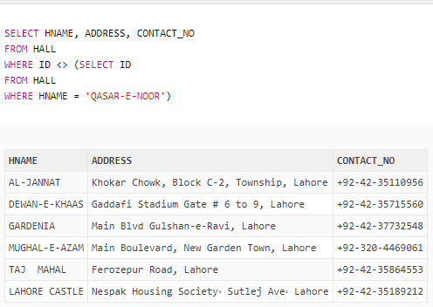

**Table**

